~ Mission ~

We are dedicated to maintaining a standard created and established by its founder. We are committed to providing dance education and developing creative talents. We emphasize being positive role models through discipline, commitment, education, and encourage the life-long love of the wonderful world of dance.

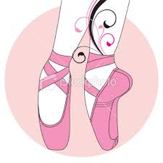
The Hamilton School of Dance offers a high quality of
instruction for all levels and ages. All classes include barre and center floor technique, combinations and routines. Class sizes are kept to a minimum to insure that every student receives individual attention.

